CPR – Super Mario 64

Home console changed the world of game significantly. The change not only in game history, but also in the game industry. A game designer or developer should quite understand the differences between home console game and arcade game. If mention home console game, we definitely need to talk about *Super Mario 64*, which is a great home console game in the game history, because of its non-linear story narrative and game saving mechanics.

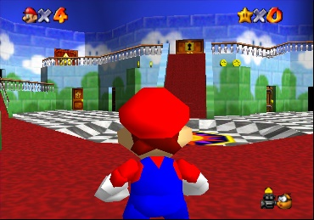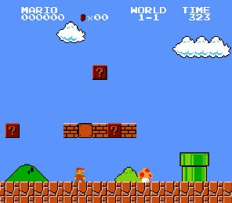One of the most significant different between home console game and arcade game is Non-linear story narrative. *Super Mario 64* arranges levels in branch mechanics. That is to say, the story is no longer following a single main course, but is set among in many subjects. For instance, Mario stands in a 3D open world at the beginning of *Super Mario 64* (shows in Figure 1). When Mario reaches the castle, he can enter different rooms (shows in Figure 2). Each room contains one level or multiple levels. Every level is relatively independent but Mario needs to collect keys or enough number of Power Stars to enter a particular level. The collection mechanics connect each level together. The whole story is constructed by the subjects in each level. Mario can go back to any level if he needs to replay find more Power Stars. In the other hand, *Mario Brothers* is set in a linear level design (shows in Figure 3). Mario just goes through each level with gradually increasing difficulty. No branch for story and Mario cannot go back to replay. And the story is only based on levels that going through. The branch mechanics make *Super Mario 64* unique, durable for playing, and player is curious to explore the open world in the game.

Figure 1

Figure 3

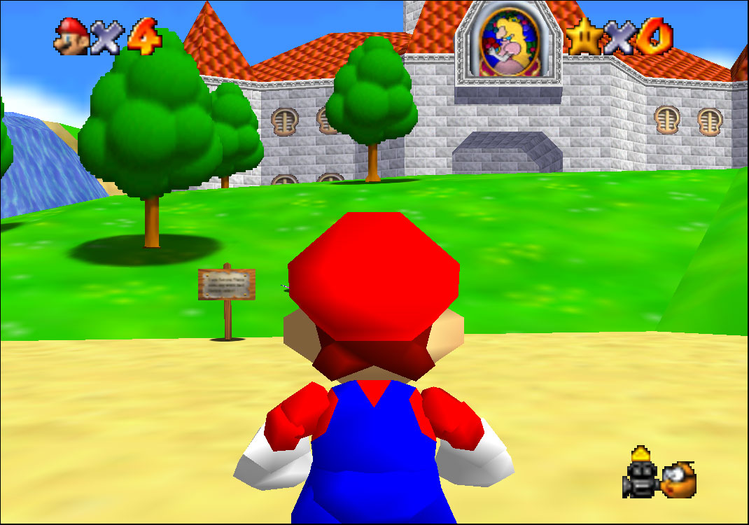

Figure 2

Besides the non-linear story narrative, another notable evolution for home console game is game saving mechanics. It means the player can save the game process and restart the game from a specific point rather than restart a new game. There is a file selection page in *Super Mario 64* (shows in Figure 4). Player can save the game process before quitting the game. When the game reopened, player can select a specifically saved file and continues to play. Avoiding restarts the whole game. The game saving mechanics is needed for home console because it is a personal system. Players saved the game process for themselves. The branched story needs to be saved process to keep player going through and prevent player gets lost in the process and loses patience in repeating play the same content. But the arcade game is different because it is a public machine and most of the story is arranged in linear. Player can easily follow the course of play. And also, arcade machine is profitable. Player needs to insert coin at the beginning or continues to play. A home console game is one-time paid when the player bought the game. So saving mechanics is also a solution to the continuity of the gameplay.

Figure 4

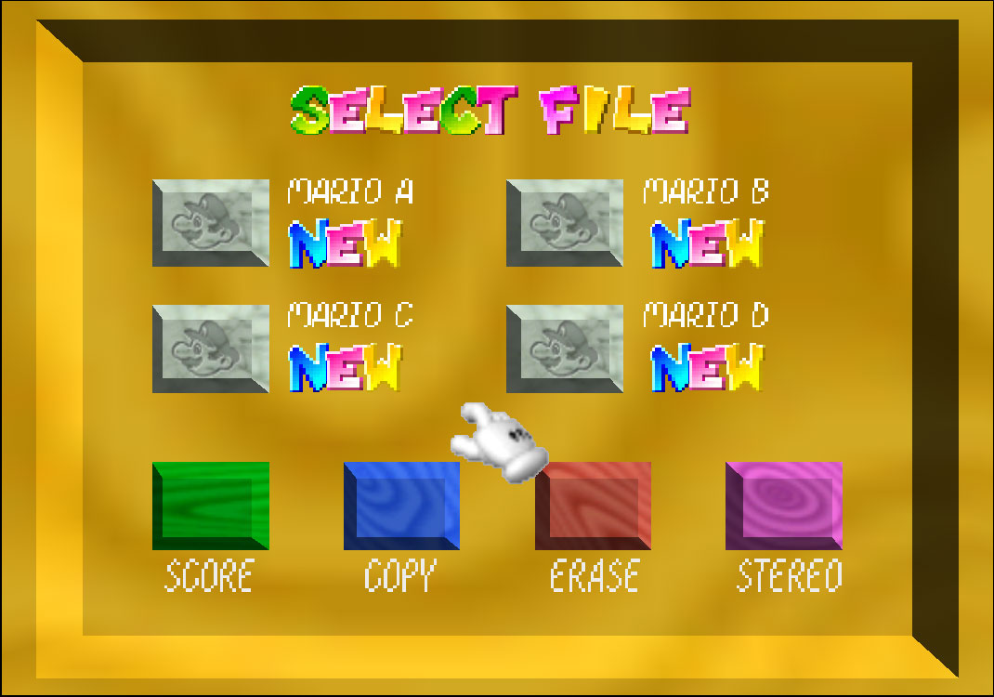

Most of arcade games arrange stories in linear. There is a main course for the story and increasing difficulties by the process of the game, which means the first level is always the easier one and the most difficult final boss is usually set in the last level. Figure 5 shows *the King of Fighters* for arcade machine. Player selects a character to challenge opponents in each level and will meet the big boss at the last level. But branch story narrative in *Super Mario 64* is distinct to linear story game. Non-linear story narrative is suitable to home console. It makes the game unique and enjoyable. Insert coins when player is dead for playing an arcade game, but restart at the last saving (checking point) if playing a home console game. The differences between home console and arcade are quite a lot. *Super Mario 64* is not only a classical home console game but also a game that represents the significant characteristics in home console games.

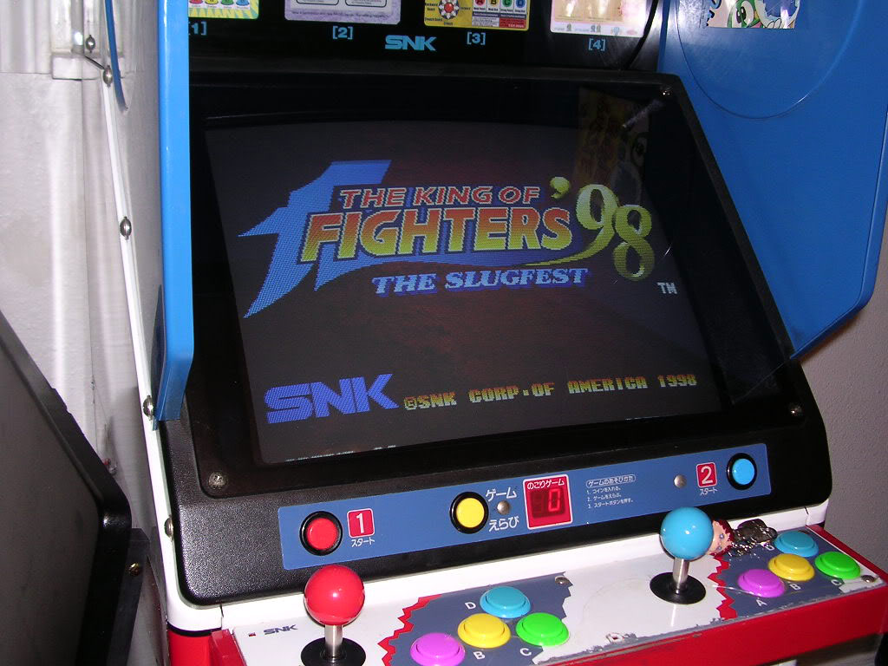

Figure 5

In summary based on what we’ve discussed above, I believe that the non-linear story narrative and game saving mechanics make *Super Mario 64* very adaptive to the home console. With non-linear story and saved game process, player can freely explore the game world and enjoy the story that happened on Mario.